JAN VAN EYCK ACADEMIE
CALL FOR APPLICATIONS
Residencies starting in 2020
Deadline: 1 October 2019, 23:59 CEST Timezone

As a post-academic, multidisciplinary institute, the Jan van Eyck Academie provides its participants with the time, space and expertise needed to develop their artistic practice in depth.

Visual artists and designers of all disciplines (graphic/fashion/food, etc.), (landscape) architects, curators, writers and researchers are invited to apply for a 12-month* residency. We welcome applications across various fields.

The Jan van Eyck's research focus will fall on water-related challenges in the Third Pole area, therefore, artists who specify in this area are encouraged to apply.

All info: www.janvaneyck.nl/apply/

*As of this year you can only apply for a 1-year residency, residencies start either in spring or autumn 2020.

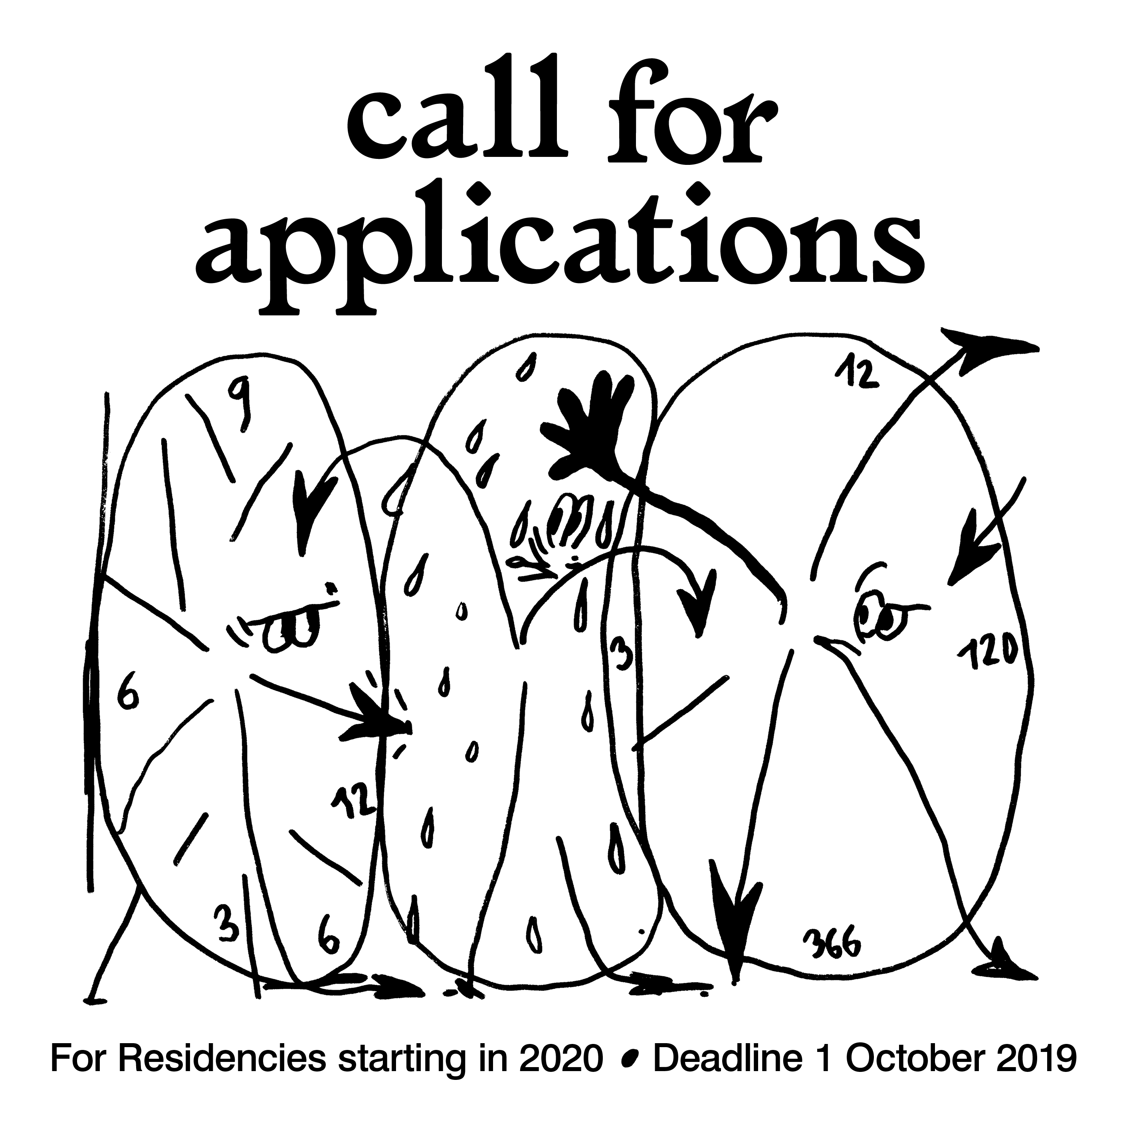

Illustration by Martin Groch, design by Atelier Brenda

